A Mini Project Report on

CALORIES BURNT PREDICTION

Submitted to

Jawaharlal Nehru Technological University, Hyderabad

in partial fulfillment of requirements for the award of the degree of

BACHELOR OF TECHNOLOGY

in

COMPUTER SCIENCE AND ENGINEERING

By

A Manisha(19BD1A0561)
G Swetha (19BD1A056G)
Laxmi Priya (19BD1A056L)
Santhosh Kumar (19BD1A0571)

Under the guidance of

Ms.Athar Fathima
Assistant Professor
Department of CSE



Department of Computer Science and Engineering

KESHAV MEMORIAL INSTITUTE OF TECHNOLOGY

Approved by AICTE, Affiliated to JNTUH

3-5-1206, Narayanaguda, Hyderabad – 500029

2022-2023


KESHAV MEMORIAL INSTITUTE OF TECHNOLOGY



(Accredited by NBA & NAAC, Approved By A.I.C.T.E., Reg by Govt of Telangana State & Affiliated to JNTU, Hyderabad)

DEPARTMENT OF COMPUTER SCIENCE AND ENGINEERING

CERTIFICATE

This is to certify that the project entitled CALORIES BURNT PREDICTION being submitted by

A MANISHA

(19BD1A0561)

G SWETHA

(19BD1A056G)


LAXMI PRIYA

(19BD1A056L)

SANTHOSH KUMAR

(19BD1A0571)

In partial fulfilment for the award of Bachelor of Technology in Computer Science and Engineering affiliated to the Jawaharlal Nehru Technological University, Hyderabad during the year 2022-23.

Internal Guide | Head of the Department
(Ms.Athar Fathima) | (Dr. S. Padmaja)
Submitted for Viva Voce Examination held on

External Examiner

Unit of Keshav Memorial Educational Society

#: 3-5-1026 Narayanaguda Hyderabad 500029.

040-3261407 www.kmit.in e-mail: principal@kmit.in

Vision of KMIT

Producing quality graduates trained in the latest technologies and related tools and striving to make India a world leader in software and hardware products and services. To achieve academic excellence by imparting in depth knowledge to the students, facilitating research activities and catering to the fast growing and ever-changing industrial demands and societal needs.

Mission of KMIT

- To provide a learning environment that inculcates problem solving skills, professional, ethical responsibilities, lifelong learning through multi modal platforms and prepare students to become successful professionals.

- To establish industry institute Interaction to make students ready for the industry.

- To provide exposure to students on latest hardware and software tools.

- To promote research based projects/activities in the emerging areas of technology convergence.

- To encourage and enable students to not merely seek jobs from the industry but also to create new enterprises.

- To induce a spirit of nationalism which will enable the student to develop, understand lndia's challenges and to encourage them to develop effective solutions.

- To support the faculty to accelerate their learning curve to deliver excellent service to students.

Vision & Mission of CSE

Vision of the CSE

To be among the region's premier teaching and research Computer Science and Engineering departments producing globally competent and socially responsible graduates in the most conducive academic environment.

Mission of the CSE

- To provide faculty with state of the art facilities for continuous professional development and research, both in foundational aspects and of relevance to emerging computing trends.

- To impart skills that transform students to develop technical solutions for societal needs and inculcate entrepreneurial talents.

- To inculcate an ability in students to pursue the advancement of knowledge in various specializations of Computer Science and Engineering and make them industry-ready.

- To engage in collaborative research with academia and industry and generate adequate resources for research activities for seamless transfer of knowledge resulting in sponsored projects and consultancy.

- To cultivate responsibility through sharing of knowledge and innovative computing solutions that benefit the society-at-large.

- To collaborate with academia, industry and community to set high standards in academic excellence and in fulfilling societal responsibilities.

PROGRAM OUTCOMES (POs)

- Engineering Knowledge: Apply the knowledge of mathematics, science, engineering fundamentals and an engineering specialization to the solution of complex engineering problems.

- Problem analysis: Identify formulate, review research literature, and analyse complex engineering problems reaching substantiated conclusions using first principles of mathematics, natural sciences, and engineering sciences

- Design/development of solutions: Design solutions for complex engineering problem and design system component or processes that meet the specified needs with appropriate consideration for the public health and safety, and the cultural societal, and environmental considerations.

- Conduct investigations of complex problems: Use research-based knowledge and research methods including design of experiments, analysis and interpretation of data, and synthesis of the information to provide valid conclusions.

- Modern tool usage: Create select, and, apply appropriate techniques, resources, and modern engineering and IT tools including prediction and modelling to complex engineering activities with an understanding of the limitations.

- The engineer and society: Apply reasoning informed by the contextual knowledge to societal, health, safety. legal und cultural issues and the consequent responsibilities relevant to professional engineering practice.

- Environment and sustainability: Understand the impact of the professional engineering solutions in societal and environmental contexts and demonstrate the knowledge of, and need for sustainable development.

- Ethics: Apply ethical principles and commit to professional ethics and responsibilities and norms of the engineering practice.

- Individual and team work: Function effectively as an individual, and as a member or leader in diverse teams and in multidisciplinary settings.

- Communication: Communicate effectively on complex engineering activities with the engineering community and with society at large, such as, being able to comprehend and write effective reports and design documentation make effective presentations, and give and receive clear instructions.

- Project management and finance: Demonstrate knowledge and understanding of the engineering and management principles and apply these to one's own work, as a member and leader in a team, to manage projects and in multidisciplinary environments.

- Life-long learning: Recognize the need for, and have the preparation and ability to engage in independent and life-long learning in the broadest context of technological change.

PROGRAM SPECIFIC OUTCOMES (PSOs)

PSO1: An ability to analyse the common business functions to design and develop appropriate Information Technology solutions for social upliftment.

PSO2: Shall have expertise on the evolving technologies like Python, Machine Learning, Deep Learning, Internet of Things (IOT), Data Science, Full stack development, Social Networks, Cyber Security, Big Data, Mobile Apps, CRM, ERP eetc..

PROGRAM EDUCATIONAL OBJECTIVES (PEOs)

PEO1: Graduates will have successful careers in computer related engineering fields or will be able to successfully pursue advanced higher education degrees.

PEO2: Graduates will try and provide solutions to challenging problems in their profession by applying computer engineering principles.

PEO3: Graduates will engage in life-long learning and professional development by rapidly adapting changing work environment.

PEO4: Graduates will communicate effectively, work collaboratively and exhibit high levels of professionalism and ethical responsibility.

PROJECT OUTCOMES

P1: Able to predict the calories burnt after the exercise.

P2: Supervised learning Algorithm.

P3: XG booster regression model was able to reduce the error.

P4: Able to describe the correlation between attributes .

LOW-1

MEDIUM - 2

HIGH - 3

PROJECT OUTCOMES MAPPING PROGRAM OUTCOMES

PO PO1 PO2 PO3 PO4 PO5 PO6 PO7 PO8 PO9 PO10 PO11 PO12

P1 2 2 3 3 3 3 2 2

P2 2 2 2 2 2 3 1

P3 2 1 1 1 2 2 1


P4 1 1 1 1 1 1

-

PROJECT OUTCOMES MAPPING PROGRAM SPECIFIC OUTCOMES

PSO | PSO1 | PSO2
P1 | 1 | 2
P2 | 2 | 2

P3 2 2

P4 1 1

PROJECT OUTCOMES MAPPING PROGRAM EDUCATIONAL
OBJECTIVES
PEO | PEO1 | PEO2 | PEO3 | PEO4
P1 | 3 | 2 | 2 | 1
P2 | 2 | 2 | 2 | 1
P3 | 2 | 2 | 2 | 2
P4 | 2 | 1 | 1 | 2

DECLARATION

We hereby declare that the project report entitled “CALORIES BURNT PREDICTION” is done in the partial fulfillment for the award of the Degree in Bachelor of Technology in Computer Science and Engineering affiliated to Jawaharlal Nehru Technological University, Hyderabad. This project has not been submitted anywhere else.

A MANISHA (19BD1A0561)

G SWETHA (19BD1A056G)
LAXMI PRIYA (19BD1A056L)
SANTHOSH KMUAR(19BD1A0571)

ACKNOWLEDGMENT

We take this opportunity to thank all the people who have rendered their full support to our project work.

We render our thanks to Dr. Maheshwar Dutta, B.E., M Tech., Ph.D., Principal who encouraged us to do the Project.

We are grateful to Mr. Neil Gogte, Director for facilitating all the amenities required for carrying out this project.

We express our sincere gratitude to Mr. S. Nitin, Director and Dr. D. Jaya Prakash, Dean Academics for providing an excellent environment in the college.

We are also thankful to Dr. S. Padmaja, Head of the Department for providing us with both time and amenities to make this project a success within the given schedule.

We are also thankful to our guide Ms.Athar Fathima, for his/her valuable guidance and encouragement given to us throughout the project work.

We would like to thank the entire CSE Department faculty, who helped us directly and indirectly in the completion of the project. We sincerely thank our friends and family for their constant motivation during the project work.

A MANISHA (19BD1A0561)

G SWETHA (19BD1A056G)

LAXMIPRIYA (19BD1A056L)

SANTHOSH KUMAR (19BD1A0571)

 | CONTENT
DESCRIPTION |  | PAGE NO.
ABSTRACT |  | i
LIST OF FIGURES |  | ii
LIST OF TABLES |  | iii
CHAPTERS
1. INTRODUCTION |  | 1-4
1.1. | Purpose of the Project | 2
1.2. | Problem with the Existing System | 2
1.3. | Proposed System | 2
1.4. | Scope of the Project | 3
1.5. | Architecture Diagram | 4
2. SOFTWARE REQUIREMENTS |  | 5-8
SPECIFICATIONS
2.1. | Requirements Specification Document | 6
2.2. | Functional Requirements | 7
2.3. | Non-Functional Requirements | 7
2.4. | Software Requirements | 8
2.5. | Hardware Requirements | 8
3. LITERATURE SURVEY |  | 9-10
4. SYSTEM DESIGN |  | 11-14
4.1. | Introduction to UML | 12
4.2. UML Diagrams |  | 12
4.3. | Use Case diagram | 12
4.4 | Sequence diagram | 14
5. IMPLEMENTATION |  | 15-18
5.1. | Pseudo code | 17

5.2. | Code Snippets
6. TESTING |  | 20-23
6.1. | Introduction to Testing | 21
6.2. | Software Test Lifecycle | 22
6.3. | Test Cases | 23
7. SCREENSHOTS |  | 24-30
7.1. | Importing libraries | 25
7.2. | Data collection and processing | 25
7.3. | Splitting the dataset into training and testing | 29
7.4. | Training the data | 29
7.5. | Comparing btw Regression and XG booster | 30
7.6. | Finding mean absolute error | 30
FURTHER ENHANCEMENTS |  | 31-32
CONCLUSION |  | 33-34
REFERENCES |  | 35-36

ABSTRACT

The overarching idea is to predict the calories burnt during the workout. We first build a machine learning system that can predict the amount of calories burnt during exercise. In today’s world many people are inquisitive about the workout that they do and the weight loss plan that they take and how much calories do they burn once they workout . But it requires regular physical activity to stay fit and healthy.
People do not concentrate on their food habits, leading to obesity. This leads people to choose their diet and do an equal amount of exercise to stay fit and healthy. The main part here is people should have adequate knowledge about their calorie intake and burn, keeping a track of their calorie intake is easy as it's available on the product label or on the internet. Keeping track of calories burnt is a difficult part as there are very few devices for that.
Calories burned by an individual are based on MET charts and formulas. The main agenda of this study is - prediction of the burnt calories with the help of an XG boost regression model as the ML (machine learning) algorithm to show accurate results. XGBoost regressor algorithm and linear regression algorithms are used to predict calories burned .
The body temperature and the heartbeat will rise when we exercise or workout. The variables that we take here such as time scale for which the individual carrying out the workout training and what is the average beats per minute and then the temperature. Then we additionally take the height,weight, gender and age of the person to predict how tons energy the person may be burning.

LIST OF FIGURES

 | LIST OF FIGURES | PAGE NO
1 | Flowchart | 4
2 | Usecase diagram | 13
3 | Representation of Correlation | 27

LIST OF TABLES

1.Test Cases 23

CHAPTER -1

1. INTRODUCTION

1.1 Purpose of Project

Regular physical activities are essential to staying healthy and fit. The estimation of calories burned by individuals is based on a formula and Metabolic equivalent charts. This study aims to predict the calories burned using a regression model as one of the machine learning algorithms to give more accurate results. Data preparation, cleaning, and analysis are the primary steps before they can be fed to the regression models.

1.2 Problems with Existing System

Though scientists have been studying metabolism for at least a century, they have not been able to measure it precisely enough — in real-world conditions, in enough people, across a broad-enough age range — to see how it changes throughout the human life span. It is clear that the bigger someone is, the more cells they have, and thus the more total calories they burn per day.
But it has been much harder to assess whether variables like age, sex, lifestyle and illness influence our rate of energy expenditure. This lack of data led to assumptions rooted in personal experience: for instance, that significant hormonal changes like those that take place during puberty and menopause cause our metabolism to speed up or slow down, prompting us to burn more or fewer calories per day; or that men have inherently faster metabolisms than women, because they seem able to shed pounds more easily; or that our energy expenditure slows in midlife, initiating gradual and inevitable weight gain.

1.3 Proposed System

Calories burned by an individual are based on MET charts and formulas. The main agenda of this study is - prediction of the burnt calories with the help of an XG boost
regression model as the ML (machine learning) algorithm to show accurate results. XGBoost regressor algorithm and linear regression algorithms are used to predict calories burned .The body temperature and the heartbeat will rise when we exercise or workout. The variables that we take here such as time scale for which the individual carrying out the workout training and what is the average beats per minute and then the temperature.

1.4 Scope of the Project

We first build a machine learning system that can predict the amount of calories burnt during exercise. In today’s world many people are inquisitive about the workout that they do and the weight loss plan that they take and how much calories do they burn once they workout . But it requires regular physical activity to stay fit and healthy. People do not concentrate on their food habits, leading to obesity. This leads people to choose their diet and do an equal amount of exercise to stay fit and healthy.

1.5 Architecture Design

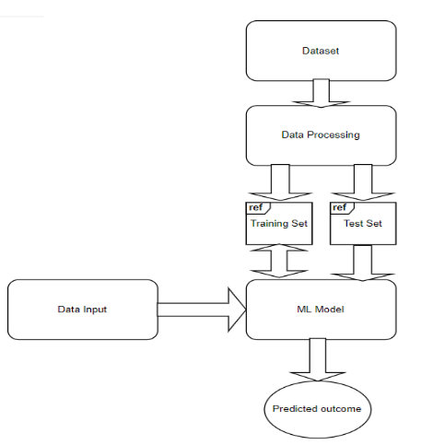

Fig1.flow chart

In order to determine how many calories an individual would burn, this study is all about gathering the right data set to train our machine learning models. Pre-processing of the records is necessary before the statistics feeding operation. After that, data processing is completed, and the data is arranged as plots and graphs using several visualisation techniques. Here we use XG Boost regressor as a ML(machine learning) model for making comparison and then evaluating these models



CHAPTER -2

2 SYSTEM RERUIREMENT SPECIFICATIONS

2.1 What is SRS?

Software Requirement Specification (SRS) is the starting point of the software developing activity. As system grew more complex it became evident that the goal of the entire system cannot be easily comprehended. Hence the need for the requirement phase arose. The software project is initiated by the client needs. The SRS is the means of translating the ideas of the minds of clients (the input) into a formal document (the output of the requirement phase.)

The SRS phase consists of two basic activities:

Problem/Requirement Analysis:

The process is order and more nebulous of the two, deals with understand the problem, the goal and constraints.

Requirement Specification:

Here, the focus is on specifying what has been found giving analysis such as representation, specification languages and tools, and checking the specifications are addressed during this activity.

The Requirement phase terminates with the production of the validate SRS 3document. Producing the SRS document is the basic goal of this phase.

2.2 Role of SRS

The purpose of the Software Requirement Specification is to reduce the communication gap between the clients and the developers. Software Requirement Specification is the medium though which the client and user needs are accurately specified. It forms the basis of software development. A good SRS should satisfy all the parties involved in the system.

2.3 Requirements Specification Document

A Software Requirements Specification (SRS) is a document that describes the nature of a project, software or application. In simple words, SRS document is a manual of a project provided it is prepared before you kick-start a project/application. This

document is also known by the names SRS report, software document. A software document is primarily prepared for a project, software or any kind of application.

There are a set of guidelines to be followed while preparing the software requirement specification document. This includes the purpose, scope, functional and non functional requirements, software and hardware requirements of the project. In addition to this, it also contains the information about environmental conditions required, safety and security requirements, software quality attributes of the project etc.

The purpose of SRS (Software Requirement Specification) document is to describe the external behaviour of the application developed or software. It defines the operations, performance and interfaces and quality assurance requirement of the application or software. The complete software requirements for the system are captured by the SRS.
This section introduces the requirement specification document for Calories Burnt prediction which enlists functional as well as non-functional requirements.

2.4 Functional Requirements

For documenting the functional requirements, the set of functionalities supported by the system are to be specified. A function can be specified by identifying the state at which data is to be input to the system, its input data domain, the output domain, and the type of processing to be carried on the input data to obtain the output data. Functional requirements define specific behaviour or function of the application. Following are the functional requirements:

FR1) The data should be in the csv format.
FR2) The training model which gives minimum mean absolute error should be used.
FR3) null values in the dataset should be filled with mean,median or mode.
FR4) Range of the data values must be normalized.

FR5) The data type of the attributes must be appropriate.

FR6) The model must predict the calories burnt

2.5 Non-Functional Requirements

A non-functional requirement is a requirement that specifies criteria that can be used to judge the operation of a system, rather than specific behaviours. Especially these are

the constraints the system must work within. Following are the non-functional requirements:

NFR 1) Must be applicable to all appropriate range of values.
NFR 2) Should not be any lag in the answer.
NFR 3) Internet Connection is essential for functioning.

NFR 4) The System should be easy to use.
NFR 5) The System should be platform independent

NFR 6) The System should be fast.

Performance:

The performance of the developed applications can be calculated by using following methods: Measuring enables you to identify how the performance of your application stands in relation to your defined performance goals and helps you to identify the bottlenecks that affect your application performance. It helps you identify whether your application is moving toward or away from your performance goals. Defining what you will measure, that is, your metrics, and defining the objectives for each metric is a critical part of your testing plan.

Performance objectives include the following:

Response time, Latency throughput or Resource utilization.

2.6 Software Requirements

Operating System | : | Windows,Mac OS,linux
Platform | : | Google Collab
Eclipse Programming Language |  | : Python

2.7 Hardware Requirements

Processor | : | Intel core i3 or above
Hard Disk | : | 2 | 56 GB and above
RAM | : | 4 GB or above.
Internet | : | 3 | Mbps

CHAPTER -3

- LITERATURE SURVEY

The variety of burned energy in day-to-day life is directly related to weight maintenance, weight gain, or weight loss. People need to burn more calories than they consume, causing a calorie deficiency. But they want to know how many calories they burn every day. Most people think that calories are most effectively associated with food and weight loss. Calories are variously defined units of energy or heat. For men or women trying to gain, lose, or maintain weight, it is essential to know how many calories they are consuming each day

CHAPTER -4

4. SYSTEM DESIGN

4.1 Introduction to UML

The Unified Modeling Language allows the software engineer to express an analysis model using the modeling notation that is governed by a set of syntactic, semantic and pragmatic rules. A UML system is represented using five different views that describe the system from distinctly different perspective. Each view is defined by a set of diagram, which is as follows:

- User Model View

This view represents the system from the users’ perspective. The analysis representation describes a usage scenario from the end-users’ perspective.

- Structural Model View

In this model, the data and functionality are arrived from inside the system. This model view models the static structures.

- Behavioural Model View

It represents the dynamic of behavioural as parts of the system, depicting he interactions of collection between various structural elements described in the user model and structural model view.

- Implementation Model View

In this view, the structural and behavioural as parts of the system are represented as they are to be built.

- Environmental Model View

In this view, the structural and behavioural aspects of the environment in which the system is to be implemented are represented.

4.2 UML Diagrams

4.2.1 Use Case Diagram

To model a system, the most important aspect is to capture the dynamic behaviour. To clarify a bit in details, dynamic behaviour means the behaviour of the system when it is running/operating.

So only static behaviour is not sufficient to model a system rather dynamic behaviour is more important than static behaviour. In UML there are five diagrams available to model dynamic nature and use case diagram is one of them. Now as we have to discuss that the use case diagram is dynamic in nature there should be some internal or external factors for making the interaction.

These internal and external agents are known as actors. So use case diagrams are consisting of actors, use cases and their relationships. The diagram is used to model the system/subsystem of an application. A single use case diagram captures a particular functionality of a system. So to model the entire system numbers of use case diagrams are used.

Use case diagrams are used to gather the requirements of a system including internal and external influences. These requirements are mostly design requirements. So when a system is analysed to gather its functionalities use cases are prepared and actors are identified. In brief, the purposes of use case diagrams can be as follows:

- Used to gather requirements of a system.

- Used to get an outside view of a system.

- Identify external and internal factors influencing the system.

- Show the interacting among the requirements are actors.

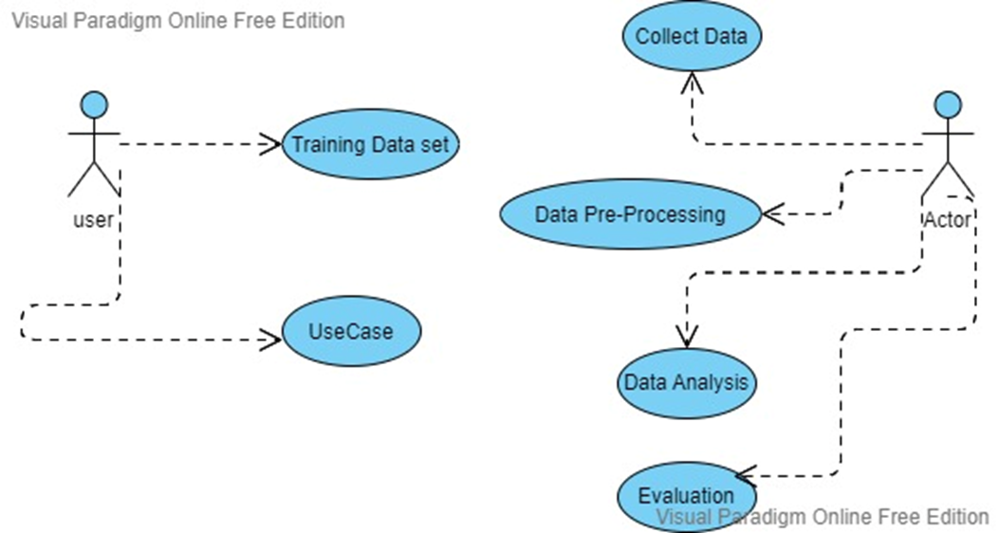

Fig 2– Use Case Diagram
4.2.2 Sequence Diagram

Sequence diagrams describe interactions among classes in terms of an exchange of messages over time. They're also called event diagrams. A sequence diagram is a good way to visualize and validate various runtime scenarios. These can help to predict how a system will behave and to discover responsibilities a class may need to have in the process of modelling a new system.

The aim of a sequence diagram is to define event sequences, which would have a desired outcome. The focus is more on the order in which messages occur than on the message per se. However, the majority of sequence diagrams will communicate what messages are sent and the order in which they tend to occur.

Basic Sequence Diagram Notations

Class Roles or Participants

Class roles describe the way an object will behave in context. Use the UML object symbol to illustrate class roles, but don't list object attributes.

Activation or Execution Occurrence

Activation boxes represent the time an object needs to complete a task. When an object is busy executing a process or waiting for a reply message, use a thin grey rectangle placed vertically on its lifeline.

Messages

Messages are arrows that represent communication between objects. Use half-arrowed lines to represent asynchronous messages.

Asynchronous messages are sent from an object that will not wait for a response from the receiver before continuing its tasks.

Lifelines

Lifelines are vertical dashed lines that indicate the object's presence over time.

Destroying Objects

Objects can be terminated early using an arrow labelled "<< destroy >>" that points to an X. This object is removed from memory. When that object's lifeline ends, you can place an X at the end of its lifeline to denote a destruction occurrence.

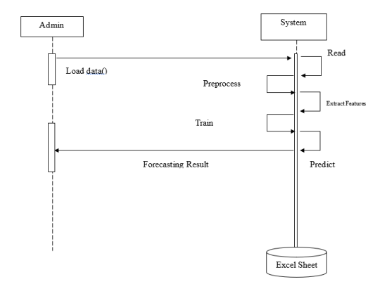
Loops

A repetition or loop within a sequence diagram is depicted as a rectangle. Place the condition for exiting the loop at the bottom left corner in square brackets []. Guards

When modelling object interactions, there will be times when a condition must be met for a message to be sent to an object. Guards are conditions that need to be used throughout UML diagrams to control flow.

CHAPTER -5

5. IMPLEMENTATION

5.1 Pseudo Code

Step1: Importing the data set
Step 2: Import the required python libraries
Step 3: Identify & drop the null fields
Step 4: Now convert the each cell into Numeric data
Step 5: Now set the dependent variables
Step 6: Use the Matplot lib library to visualize the data
Step 7: Processing the data and analyzing.
Step 8:Finding the Correlation between the attributes.
Step 8: Train the model
Step 9: Comparing the linear regression model and XG booster regression model
Step 10: As XG booster regression models gives low error ,proceed with this model
Step 9: Use the XG booster regression model for Analysis
Step 10:This Model is ready for calories burnt prediction.

5.2 Code Snippets

import numpy as np
import pandas as pd
import matplotlib.pyplot as plt
import seaborn as sns
from sklearn.model_selection import train_test_split
from xgboost import XGBRegressor
from sklearn import metrics

# loading the data from csv file to a Pandas DataFrame
calories = pd.read_csv('/content/calories.csv')

# print the first 5 rows of the dataframe
calories.head()

exercise_data = pd.read_csv('/content/exercise.csv')
exercise_data.head()

calories_data = pd.concat([exercise_data, calories['Calories']], axis=)
calories_data.head()

# checking the number of rows and columns
calories_data.shape

# getting some informations about the data
calories_data.info()

# checking for missing values
calories_data.isnull().sum()

# get some statistical measures about the data
calories_data.describe()

sns.set()

# plotting the gender column in count plot
sns.countplot(calories_data['Gender'])

# finding the distribution of "Age" column
sns.distplot(calories_data['Age'])

# finding the distribution of "Height" column
sns.distplot(calories_data['Height'])

# finding the distribution of "Weight" column
sns.distplot(calories_data['Weight'])
sns.distplot(calories_data['Weight'])

correlation = calories_data.corr()

plt.figure(figsize=(10,10))
sns.heatmap(correlation, cbar=True, square=True, fmt='.1f', annot=True,annot_kws={'size':8}, cmap='Blues')

calories_data.replace({"Gender":{'male':0,'female':1}}, inplace=True)

calories_data.head()

X = calories_data.drop(columns=['User_ID','Calories'], axis=1)
Y = calories_data['Calories']
print(X)
print(y)

X_train, X_test, Y_train, Y_test = train_test_split(X, Y, test_size=0.2, random_state=2)

print(X.shape, X_train.shape, X_test.shape)

XGBoost Regressor

# loading the model
model = XGBRegressor()

# training the model with X_train
model.fit(X_train, Y_train)

Prediction on Test Data
test_data_prediction = model.predict(X_test)

print(test_data_prediction)

Mean Absolute Error
mae = metrics.mean_absolute_error(Y_test, test_data_prediction)
print("Mean Absolute Error = ", mae)

#training the model with linear Regression
from sklearn.linear_model import LinearRegression
clf = LinearRegression()clf.fit(X_train,Y_train)
ad=clf.predict(X_test)
mae = metrics.mean_absolute_error(Y_test,ad )
print("Mean Absolute Error = ", mae)

CHAPTER -6
6. TESTING

6.1 Introduction to Testing

Testing is the process of evaluating a system or its component(s) with the intent to find whether it satisfies the specified requirements or not. Testing is executing a system in order to identify any gaps, errors, or missing requirements in contrary to the actual requirements.

According to ANSI/IEEE 1059 standard, Testing can be defined as - A process of analyzing a software item to detect the differences between existing and required conditions (that is defects/errors/bugs) and to evaluate the features of the software item.

Who does Testing?


It depends on the process and the associated stakeholders of the project(s). In the IT industry, large companies have a team with responsibilities to evaluate the developed software in context of the given requirements. Moreover, developers also conduct testing which is called Unit Testing. In most cases, the following professionals are involved in testing a system within their respective capacities:

- Software Tester

- Software Developer

- Project Lead/Manager

- End User

Levels of testing include different methodologies that can be used while conducting software testing. The main levels of software testing are:

- Functional Testing

- Non-functional Testing

Functional Testing

This is a type of black-box testing that is based on the specifications of the software that is to be tested. The application is tested by providing input and then the results are examined that need to conform to the functionality it was intended for. Functional testing of a software is conducted on a complete, integrated system to evaluate the system's compliance with its specified requirements.

6.2. Software Testing Life Cycle

The process of testing a software in a well-planned and systematic way is known as software testing lifecycle (STLC).

Different organizations have different phases in STLC however generic Software Test Life Cycle (STLC) for waterfall development model consists of the following phases.

- Requirements Analysis

- Test Planning

- Test Analysis

- Test Design

- Requirements Analysis

In this phase testers analyze the customer requirements and work with developers during the design phase to see which requirements are testable and how they are going to test those requirements.

It is very important to start testing activities from the requirements phase itself because the cost of fixing defect is very less if it is found in requirements phase rather than in future phases.

- Test Planning

In this phase all the planning about testing is done like what needs to be tested, how the testing will be done, test strategy to be followed, what will be the test environment, what test methodologies will be followed, hardware and software availability, resources, risks etc. A high level test plan document is created which includes all the planning inputs mentioned above and circulated to the stakeholders.

- Test Analysis

After test planning phase is over test analysis phase starts, in this phase we need to dig deeper into project and figure out what testing needs to be carried out in each SDLC phase. Automation activities are also decided in this phase, ifautomation needs to be done for software product, how will the automation be done, how much time will it take to automate and which features need to be

automated. Nonfunctional testing areas(Stress and performance testing) are also analyzed and defined in this phase.

- Test Design

In this phase various black-box and white-box test design techniques are used to design the test cases for testing, testers start writing test cases by following those design techniques, if automation testing needs to be done then automation scripts also needs to written in this phase.

Test cases
Machine Learning Model | Input data | Predicted calorie result | Expected calorie result
XG Booster Regression model | Male{0},68,190.0,94.0,29.0,105.0,40.8 | 230.33 | 231.0
XG Booster Regression model | Male{0},63,173.0,79.0,18.0,92.0,40.5 | 95.0 | 98.0
XG Booster Regression model | Female{1},43,159.0,58.0,16.0,90.0,40.1 | 71.8 | 75.0
XG Booster Regression model | Female{1},27,165.0,65.0,6.0,85.0,39.2 | 21.72 | 23.0

CHAPTER -7
SCREENSHOTS

7.1 Importing libraries-
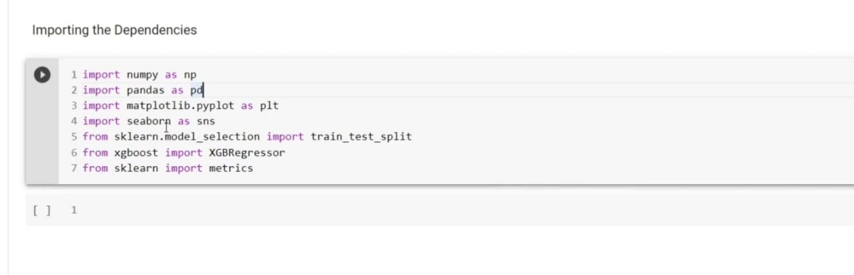

7.2 Data collection and processing-

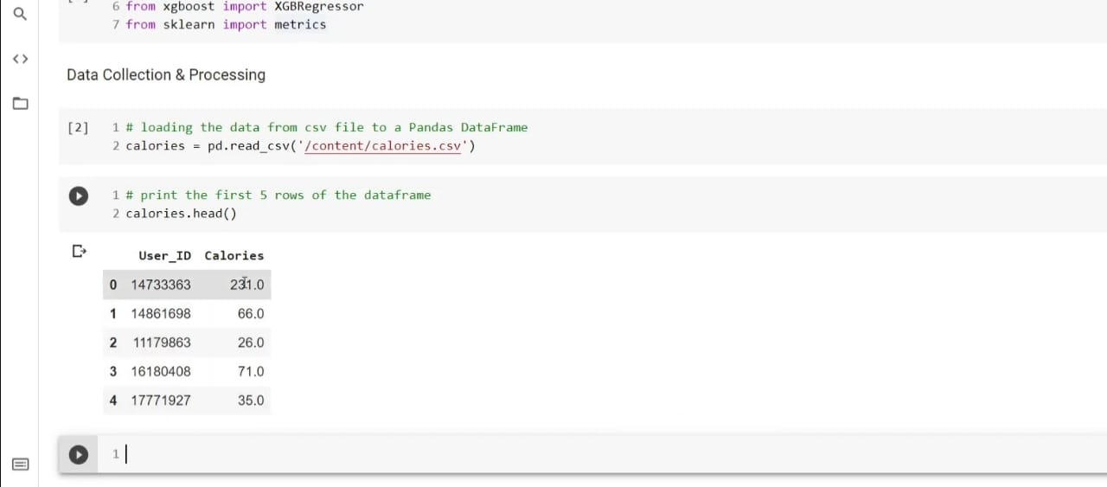

Shape of the dataset,no of null ,non null values-
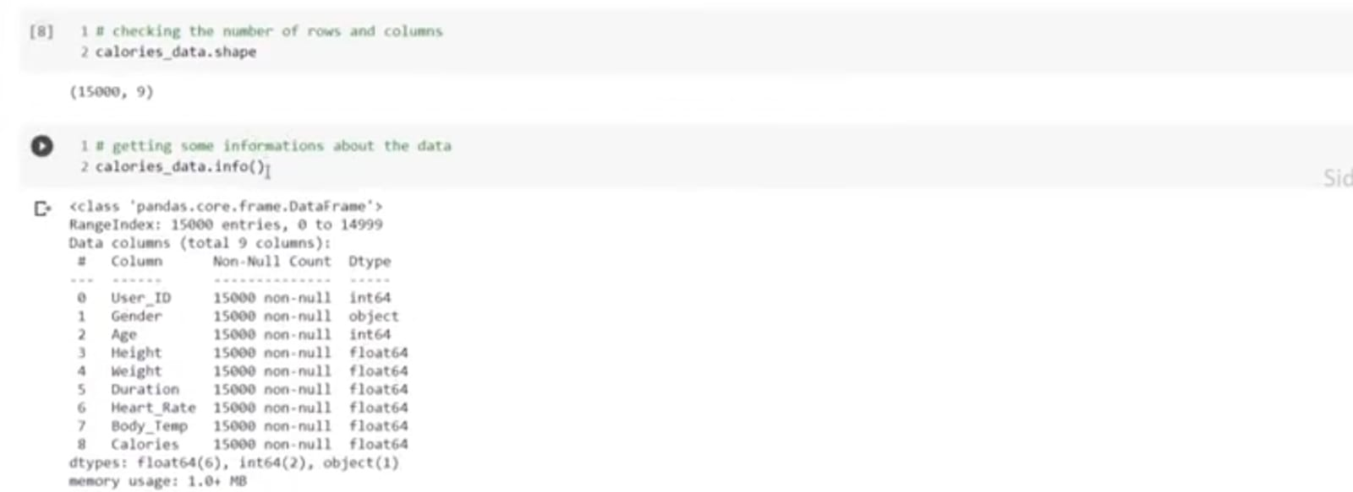

Description of dataset-

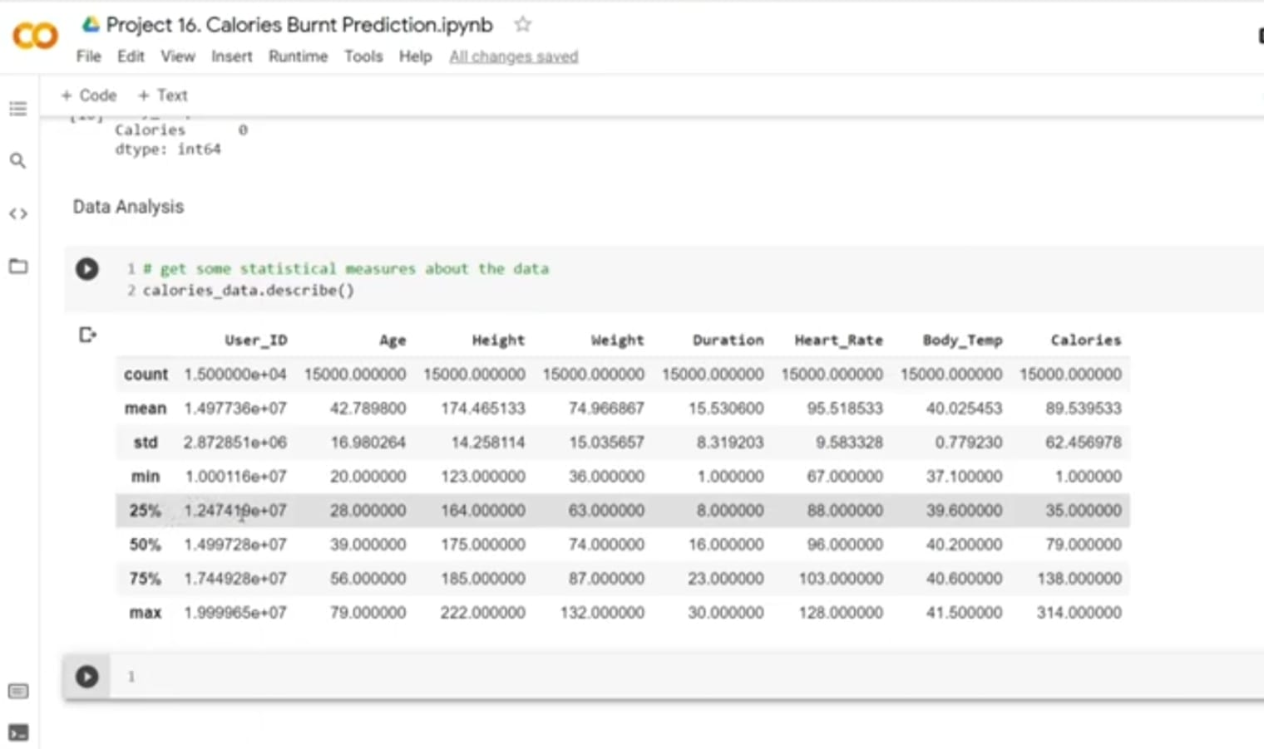

Correlation between the attribures-

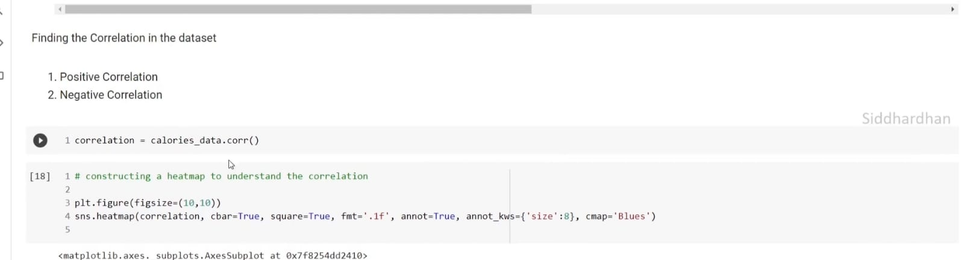

f

Fig.3.Representation of correlation-

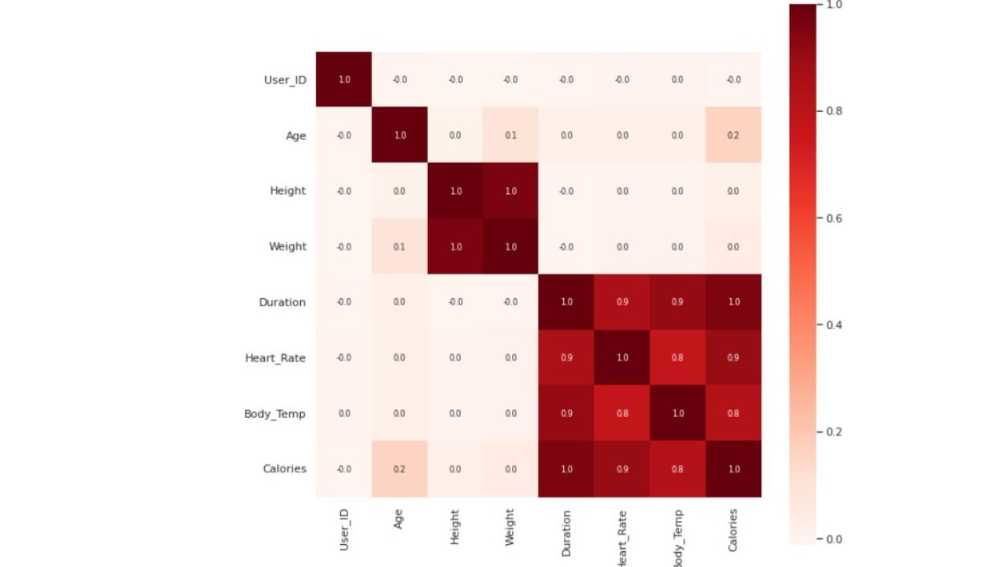

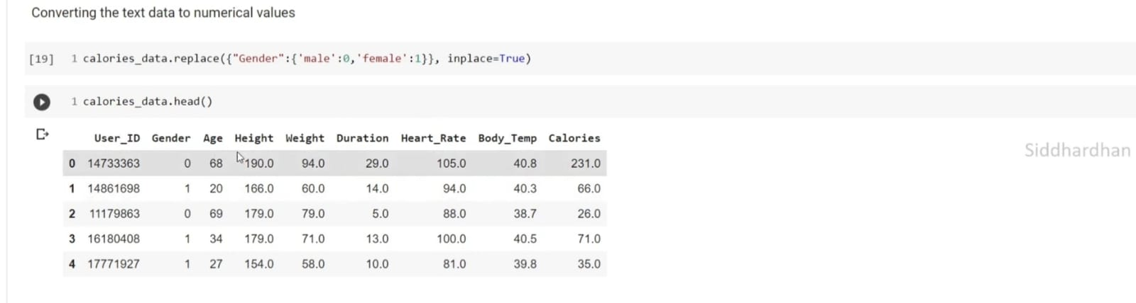
-Labelling male and female as 0 ,1

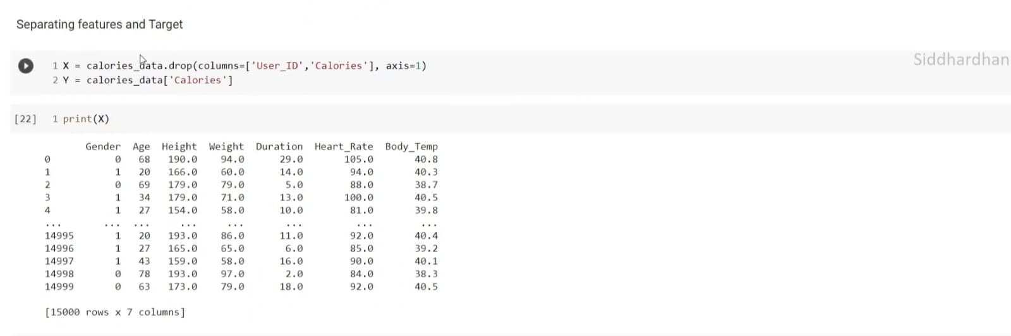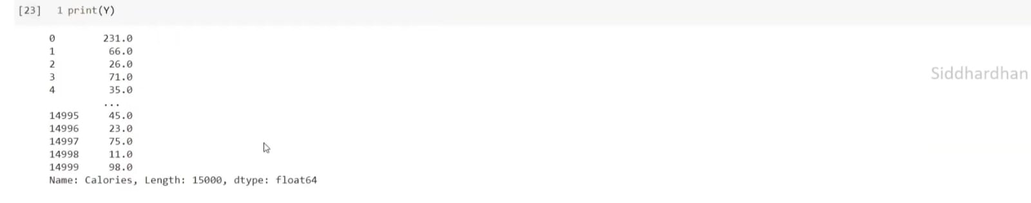
-Dropping the id,calories attributes from the data and storing in X

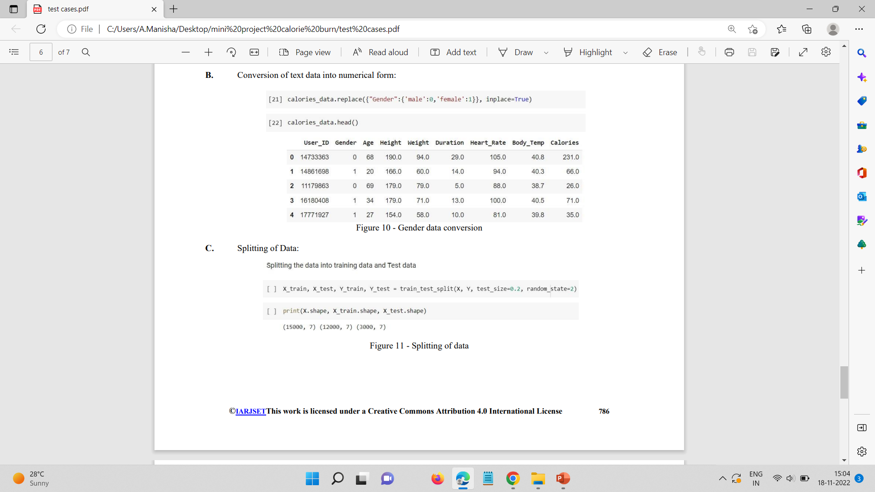
7.3-Splitting the data into xtrain,xtest,ytrain,ytest.

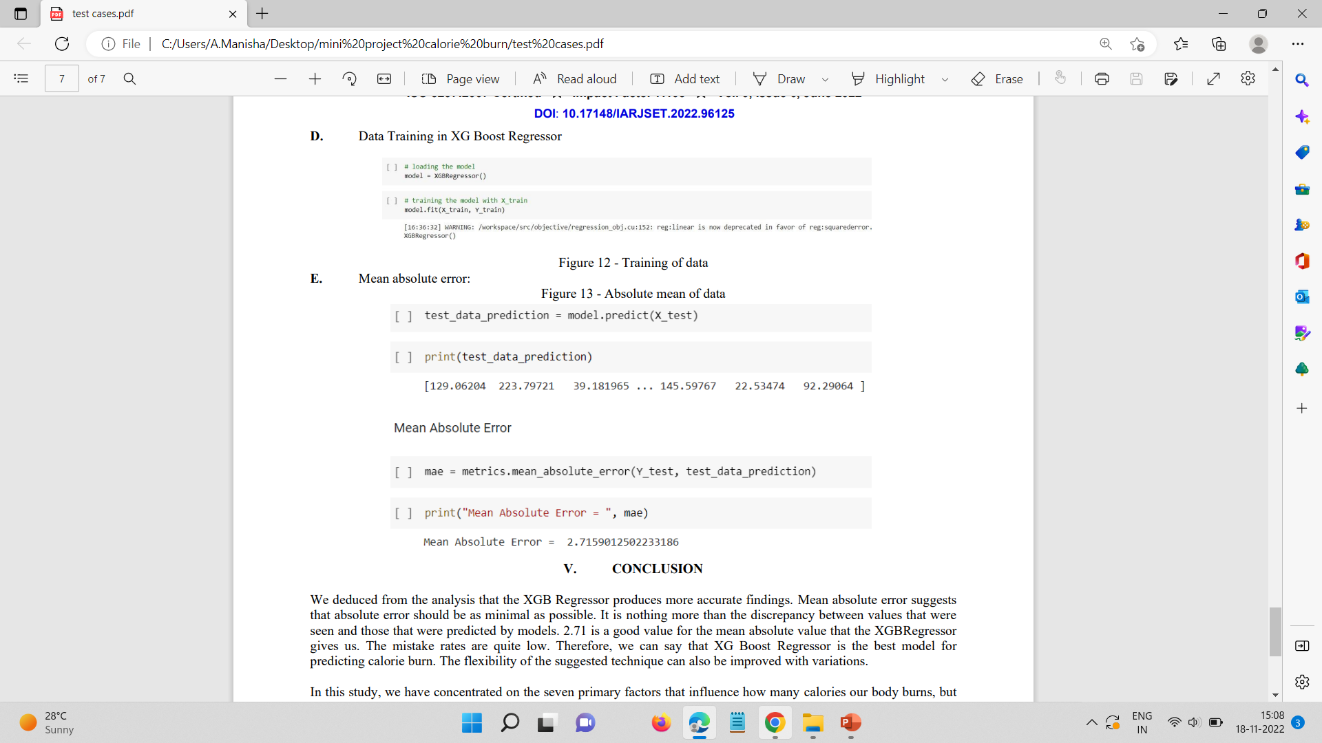

7.4-Training the data using XG booster regression model.
-Finding the absolute error with actual and predicted values.

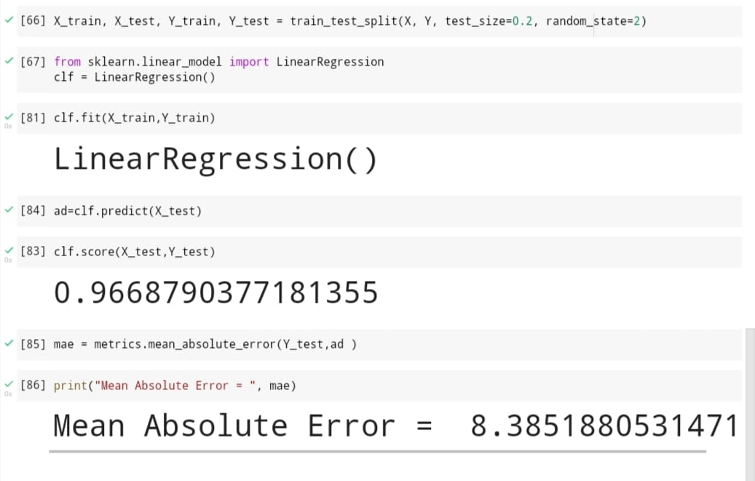
7.5 -Comparing between linear regression model and XG booster

CHAPTER-8

Further Enhancements:

Data: As data has 15000 rows,collecting such a huge data in real life is a complex task with its attributes of an each individual.

Values: The database of calories burnt prediction is the database where the values for each attribute of an individual is collected,the results of such huge database is generated at a go, but as the data is in the form of csv ,there might be a chance of values out of range ,which need to be normalized.

Error: As the model used is XG booster regression model the error value is less but the error cant be avoided and also collecting such huge data is a complex task .

Model:XG booster regression model is better than regression model and also less compared to.

CHAPTER -10
CONCLUSION

From the analysis we met with a conclusion that the XGB Regressor has more accurate results than the Linear regression model. Mean absolute error imply absolute error ought to be as low as viable.. it is not anything but the difference between the actual and predicted values through the models. The mean absolute error value that is getting in XGB Regressor is 2.71 which is a good value.The error values is very less. Therefore we can conclude that the best model for the calorie burn prediction is XGBoost Regressor.

The analysis of this dataset was done to predict the calories burned depends on the duration of workout and also based on the gender, age，body temperature and heart rate at some stage in the exercise. By using these machine learning algorithms we are looking for a machine learning model with less mean absolute error, which gives more accurate results. By comparing the two models, XGB regressor and Linear regression we get that the XGB Regressor gives the more accurate results of the calories burned with a mean absolute error of 2.71 than the linear regression.

CHAPTER -10

REFERENCES

- Smola, A., & Vishwanathan, S. V. N. (2008). Introduction to machine learning. Cambridge University.
- MacKay, D.J, & Mac Kay, D. J. (2003). Information theory, inference and learning algorithms.Cambridge University press.
- Mitchell, T. M. (1999). Machine learning and data mining. Communications of the ACM
- https://www.kaggle.com/fmendes/fmendesdat263xdemos
- https://machinelearningmastery.com/xgboost-for- regression/
- https://www.medicalnewstoday.com/articles/319731#factors-influencing-daily-calorie-burn-and-weight-loss
- https://zenodo.org/record/6365018
- https://devhadvani.github.io/calorie.html
- https://www.ncbi.nlm.nih.gov/pmc/articles/PMC5496172
- https://www.jetpac.com/
- World Health Organization. (2011, October) Obesity Study. [Online]http://www.who.int/mediacentre/factsheets /fs311/en/index.html

